


Nom : COELHO FERNANDES

Master 2 SD Prénom : Rodrigo César

Machine Learning in Sequences

Séance de TP 2
Hidden Markov Models (HMM)
Forward-Backward versus Viterbi training

- Training HMM with the forward-backward algorithm
- Use the given program to train the 10 digit models. At each iteration of the EM algorithm the model is tested on the validation dataset by calling the Log_likelihood(valid_data) method. The best model is saved through the iterations. The number of EM iterations is fixed to Max_EM_iter

- Comment and analyze the training and validation loss (images saved)

- Run the recognition step on the MNIST test dataset composed of 10 000 digit images by putting TRAINING = False

- Fill in the table below where RR stand for the Recognition Rate computed on un-seen examples during training, i.e. on the test set made of 10 000 examples.

- Draw some conclusion.

N_train | n_cluster | n_states | RR (%) test
10 000 | 50 | 5 | 84.98 %
 | 50 | 10 | 88,94 %
 | 50 | 15 | 90.64 %
 | 100 | 5 | 87.04 %
 | 100 | 10 | 90.64 %
10 000 | 100 | 15 | 91.42 %
54 000 | 100 | 15 | 89.98 %

During the training of each class, most of the likelihood curves for both training and validation exhibited the expected behavior, that is, an initial growth phase followed by stagnation for the training curve and a decrease for the validation curve, as shown in the Figure 1. Therefore, the models with the highest validation likelihood were selected.
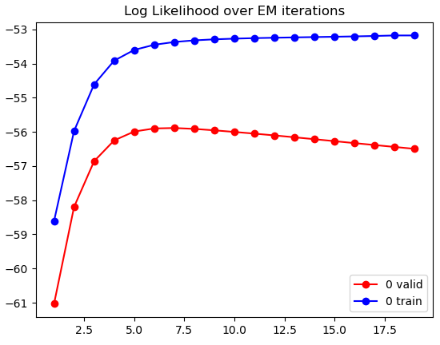
Figure 1 – Log Likehood curve with the most observed behavior.

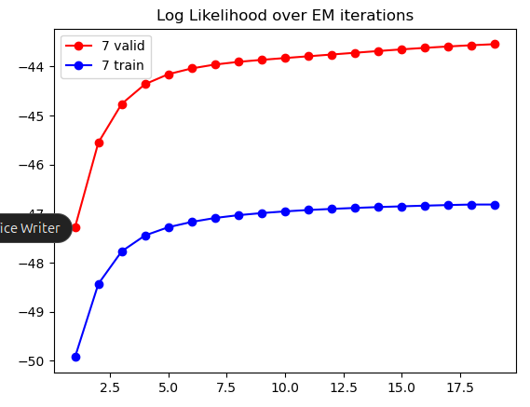
It should be noted that there were classes where the validation curve performed better than the training curve. This is possible if the validation dataset is simpler or has a less dispersed distribution. This behavior can also be observed in the Figure 2.
Figure 2 – Log Likehood curve with higher validation values.

There were also cases where the training did not converge within the 20 epochs, meaning that the validation likelihood curve was still in a growth phase, which can also be seen in the Figure 2. This indicates that increasing the number of epochs could improve the final recognition rate (RR), but at the cost of longer training time.

As expected, the recognition rate is higher for larger numbers of states and clusters, reaching 91.42% for the best model with 10.000 examples. It is important to highlight that RR values above 99% can be achieved with simple CNNs or other classification models on the MNIST dataset, which indicates that this model did not perform well.

Regarding the size of the training dataset, the results of the model trained with 54.000 examples were not better than those obtained with only 10.000 examples. The additional examples may have introduced greater variability in the data, which the Forward-Backward model was not robust enough to learn effectively. Moreover, the training time was considerably longer, suggesting that increasing the number of examples may not be advantageous for the Forward-Backward model.

- Training HMM with the Viterbi algorithm
- Use the given program to train the 10 digit models. At each iteration of the EM algorithm the model is tested on the validation dataset by calling the Log_likelihood(valid_data). The best model is saved through the iterations. The number of EM iterations is fixed to Max_EM_iter

- Comment and analyze the training and validation loss through the epochs, compare the curves with those of the froward Backward training.

- Run the recognition step on the MNIST test dataset composed of 10 000 digit images by putting TRAINING = False

- Fill in the table below and draw some conclusion by comparing these results with those obtained using Forward Backward training.

N_train | n_cluster | n_states | RR (%) test
10 000 | 50 | 5 | 81.57 %
 | 50 | 10 | 85.2 %
 | 50 | 15 | 87.78 %
 | 100 | 5 | 84.78 %
 | 100 | 10 | 88.04 %
10000 | 100 | 15 | 89.4 %
54 000 | 100 | 15 | 81.24 %

It is evident that training using the Viterbi method was faster than with the Forward-Backward method, however, it yielded a lower recognition rate. This may have been caused by the frequent convergence to local minima. Observing the evolution of the likelihood over time, we see that there is no significant increase as training progresses, which suggests that the algorithm was trapped in a local minimum, as shown in Figure 3.

Figure 3 – Log Likehood curve with small increase in training.
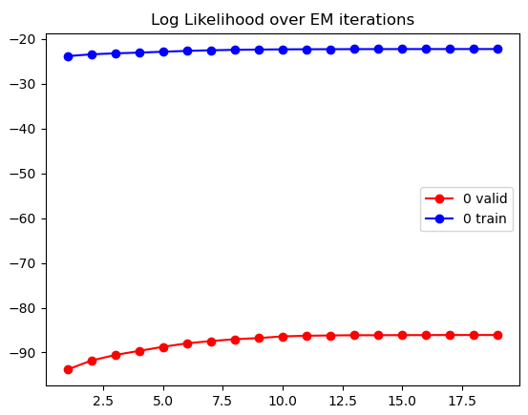
It can be said that the Viterbi method works but tends to fall into local minima. This may be related to the fact that the method operates based on a sequence of hidden states, making binary predictions, thus, a poor initial prediction can negatively affect the final result. On the other hand, the Forward-Backward method computes an average and retains all the information, preventing it from being consistently driven in the wrong direction.

Again, increasing the number of training examples to its maximum of 54.000 digits led to a decrease in RR, suggesting that the variability introduced by the additional examples increases the complexity of the data, which hinders the model’s ability to represent it effectively.

Figure 3 – Result of RR for 54.000 test exemples.

